Slider Item Component

For this Component, first we need to add slider component.

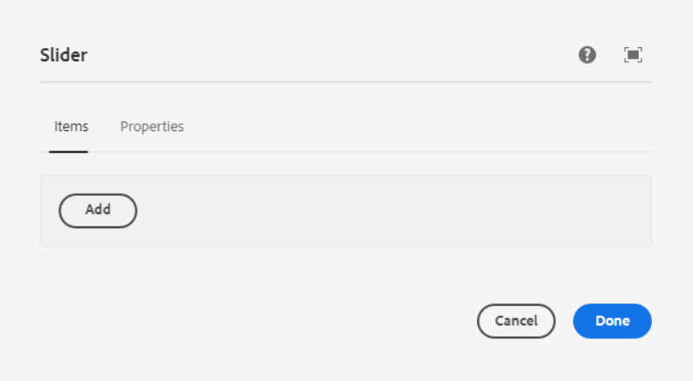

Inside Items Tab, we can add Slider items component.

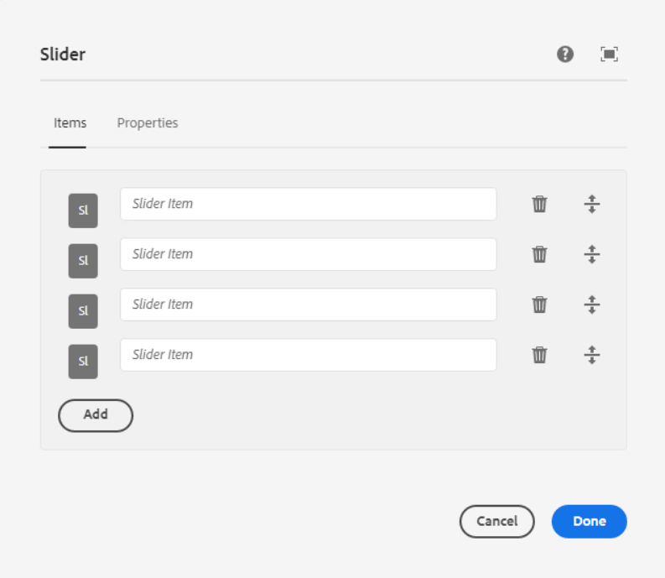  
In Editor mode, we can able to see slider item inside the slider component.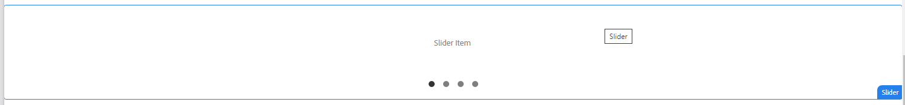

___________________________________________________________________Configure Slider Item Component

Properties Tab

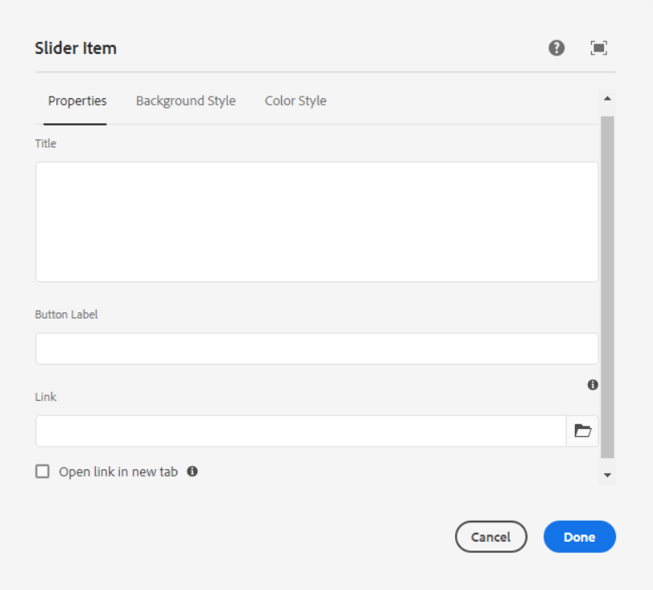

**Title** – This is for Title of the slider

**Button Label** – This is for button text

**Link** – This is whole slider item link

**Checkbox For open link in new tab**

___________________________________________________________________

Background Style Tab

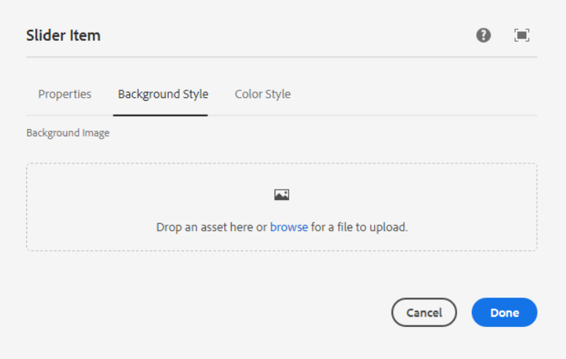

**Background Image** – Here we can edit, clear or pick any image as per the requirement.

___________________________________________________________________

Color Style Tab

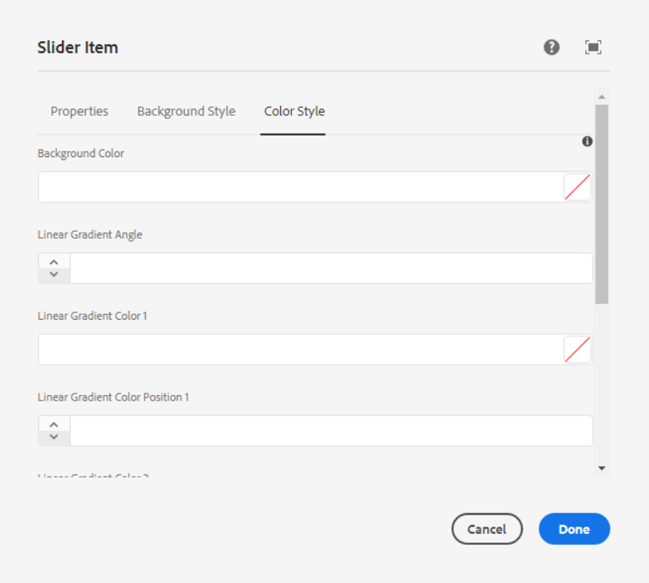

**Background Color** – Pick any color as per our requirement in hex or RGBA format.

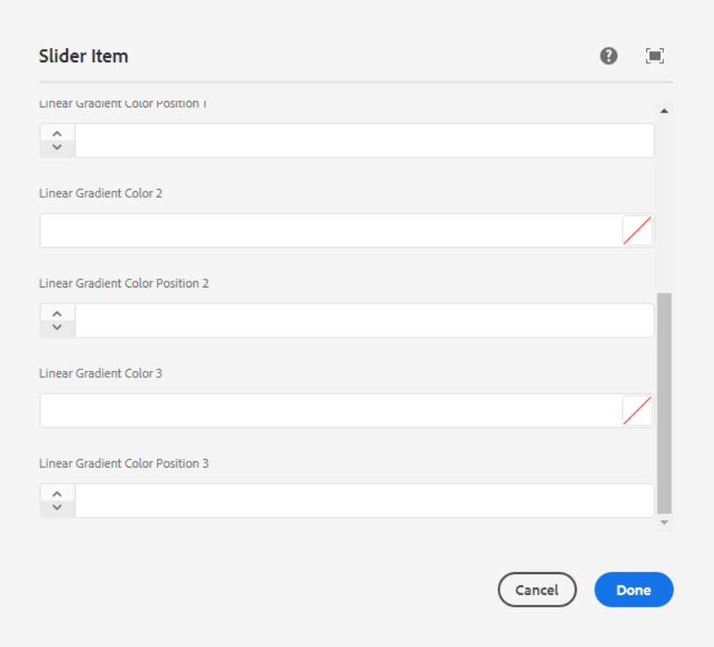

**Linear Gradient Angle** – Here we can set the angle of the background Image

**Liner Gradient Color and Liner Gradient Color Position** – Here we have 3 options to add color and position.

___________________________________________________________________

We can achieve below design, after authoring slider and slider item component.

Page Reference - <https://www.ancestry.com/corporate/corporate-responsibility>

AEM URL - [https://author-ancestry-dev2.adobecqms.net/content/ancestry-corp/us/en](https://author-ancestry-dev2.adobecqms.net/content/ancestry-corp/us/en/about-ancestry/our-team.html?wcmmode=disabled)[/corporate-responsibility.html?wcmmode=disabled](http://localhost:4502/content/ancestry-corp/us/en/corporate-responsibility.html?wcmmode=disabled)



But now on the AEM page, the above slider data is coming dynamically for blog pages only. We just need to select the checkbox from the Slider component.

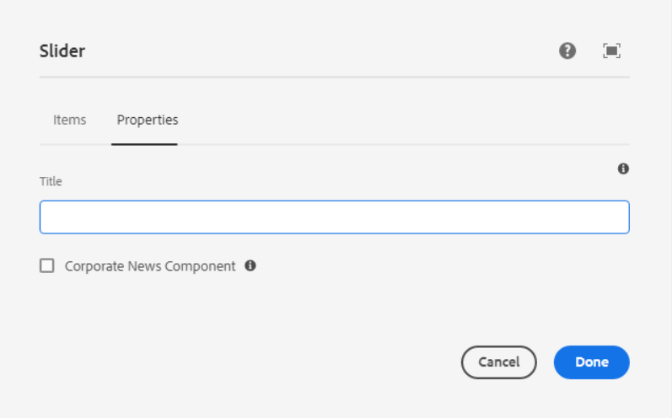

**Checkbox for corporate News component** - Check this to populate the component with corporate news blog page content.